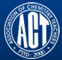 Association of Chemistry Teachers (ACT)
C/o. Homi Bhabha Center for Science Education (HBCSE), TIFR, Mumbai-400 088

News Letter Issue-5/ May - August, 2016

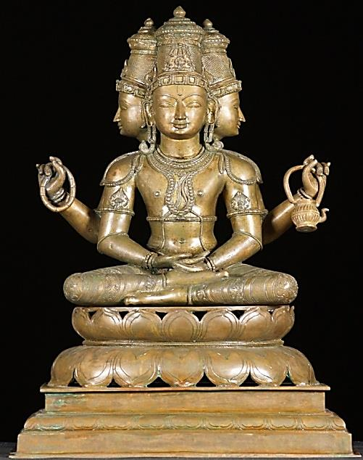
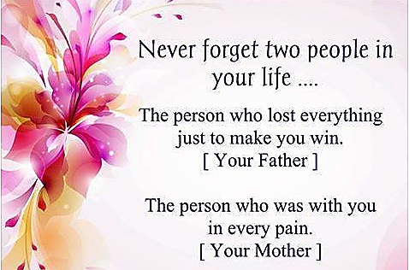
From the Editor’s Desk
Our constant endeavor is to update our readers on current trends in chemical research and chemistry education. Our focus is on latest Nobel Laureates in Chemistry; the life history of
famous Nobel laureates in science towards motivation to our student community, academicians and scientists; and a few interesting developments in scientific research across the globe. We also present the progress of ACT – activities during the period under consideration. Achievements, Awards and Rewards are other aspects covered in our issues, so as to motivate younger generation towards reaching greater heights. We solicit thought provoking and innovative articles from the fraternity of ACT. Wishing you all, a Happy Independence Day; and Ganesh Chaturdhi.

With warm regardsDr. M. R. R. PRASAD

NEWS
SCIENCE RESEARCH
Emma Stoye
Programmable DNA Nano thermometers
Tiny fragments of DNA combined with fluorescent probes used to take temperature

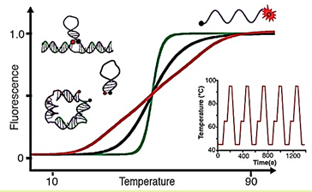Vallée–Bélisle and his team tuned short DNA strands to unfold at different rates to make a ultrasensitive molecular thermometers for small temperature ranges. (© American Chemical Society)

The smallest ever molecular thermometers have been made by researchers in Canada using fragments of DNA that slowly unfold to release fluorescent molecules. The DNA thermometers are capable of extraordinary sensitivity, and the team behind them says they could be used to track minute temperature changes within cells or nanodevices.

Just like the way DNA is synthesized for PCR applications: using a DNA synthesizer and phosphoramidite chemistry, the thermometers were synthesized, and developed the nano-scale devices at the University of Montreal. The DNA thermometers self-assemble but their structures are temperature sensitive. As the temperature increases the folded structure becomes unstable and unfolds. The thermometers contain fluorophores which are released during the process, so the temperature can be linked to an easily detectable optical signal.

The DNA can be programmed using stabilizers to unfold at different rates, which makes the thermometers more or less sensitive. The working team could create very sensitive temperature probes that unfolded and released a large shot of fluorophores over a temperature change of just 0.05ºC. Alternately, the thermometers can be programmed in such a way that they have an extended dynamic range and unfold over a large change in temperature of the order of 50ºC.

The thermometers could be useful for several research applications, including taking the temperature of different parts of cells or very small structures. Vallée-Bélisle’s team is currently using them to measure the temperature around the cell’s nanomotors and nanomachines to see if they overheat when running.

Seiichi Uchiyama from the University of Tokyo, japan, agrees that the thermometers could have similar applications to polymer-based molecular thermometers, which his own team have developed in recent years to measure intracellular temperatures. According to Seiichi Uchiyama, the important thing is that DNA is a familiar molecule for the biologists who want to perform cellular thermometry. However, he feels that there may be obstacles in using DNA-based devices in biological systems. The DNA thermometers can easily interact with the endogenous biomolecules, which might interfere with their function.

According to A Prasanna de Silva at the school of chemistry and chemical engineering, Queen’s University, Belfast, UK, while molecular thermometers based on synthetic polymers and small molecules are well-established, it is important to widen the structural base of such devices. Therefore it is good to see DNA-based versions appearing. When compared to older studies with simple stem-loop configurations, the work by Gareau et al now brings a ready adjustability in terms of the sensitive temperature range and dynamic range. The application of the technique to PCR wells is a good demonstration, though it would be better if future experiments were to tackle far smaller spaces as some of the synthetic polymer thermometers have done, he says.

Reference:
D. Gareau, A. Desrosiers and A. Vallée–Bélisle, Nano Let., 2016, DOI: 10.1021/acs.nanolett.6b00156
===========================================================================
Awards & Rewards

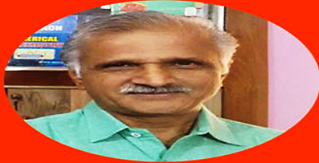 Prof. Prem Mohan Mishra, Vice-President, ACT – Eastern Zone was conferred Highest Children’s Literature Award – 2016 for his writings in Maithili Language, by the Sahitya Academy, a Government of India Organization.

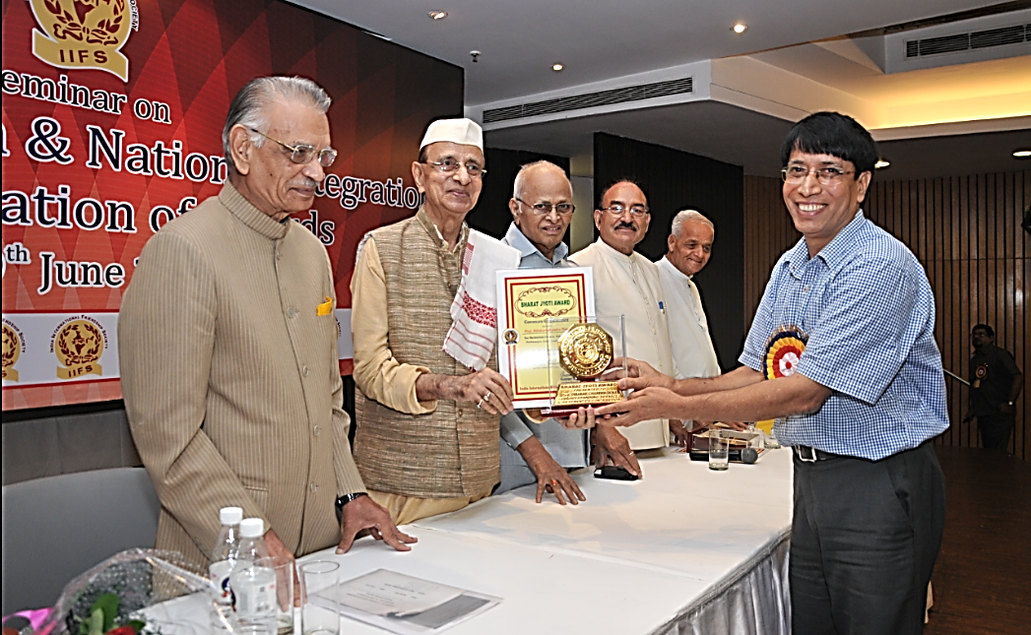 Bharat Jyoti Award was presented by Dr. Bhishma Narain Singh, Former Governor of Tamil Nadu and Assam, at the seminar on “Economic Growth & National Integration,” New Delhi, held on June 09, 2016; to Prof. Dibakar Chandra Deka, Vice-President, ACT- North Eastern Zone, for his meritorious services, outstanding performance and remarkable role.
Prof. (Dr.) K. Sudhakarbabu, Co-opted member, ACT- Southern Zone, and Professor at Department of Chemistry, Sri Krishnadevaraya University, Anantapuram, Andhra Pradesh has been nominated as Executive Council Member of this University with effect from February 22, 2016.
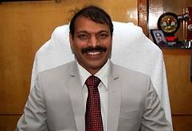 Prof. G. Nageswara Rao, Life-Member, ACT, has been appointed as the Vice-Chancellor of Andhra University, Visakhapatnam.
Prof. (Dr.) M. V. Basaveswara Rao, Life-Member, ACT-Southern Zone, and Professor at Department of Chemistry, Krishna University, Machilipatnam, Andhra Pradesh has been nominated as Executive Council Member of this University with effect from February 22, 2016.
48Th International Chemistry Olympiad:
48th International Chemistry Olympiad (IChO – 2016) was held in Tbilisi; Georgia was concluded on August 01, 2016. India was ranked 6th, behind China (4 Gold); Russia, South Korea, Taiwan and Romania (3 Gold and 1 silver each). There were 264 students participated from 65 countries in this IChO-2016. Special credits need to be given to Mr. Sharvik Mittal, who received silver medal, in spite of the fact that he had a tragic loss of his mother in a road accident, barely two weeks before the Olympiad.

This is the second grand event (first one being in the year 2001) that, every Indian participants in all three core subjects (Physics, Chemistry and Biology) Olympiads have won either Gold or Silver medals. The total medal tally in these subjects (6 – Gold and 7 silver) is the best ever. The winning candidates need a special mention:

Mr. Valay Agarawal – Gold; Utkarsh Gupta – Gold
Sharvik Mittal – Silver; Kartik Patekar – Silver

The team was accompanied by two leaders – Prof. Arvind A. Natu of IISER, Pune; and Prof. Avinash Kumbhar of University of Pune. Two Scientific Observers accompanied the team include – Prof. Anindya Datta of IIT, Mumbai; and Dr. Ankush Gupta of HBCSE, Mumbai. ACT extends heartfelt congratulations to all winners, teachers and mentors across the nation, and most importantly, the Chemistry Olympiad Cell of Homi Bhabha Centre for Science Education (HBCSE), TIFR, Mumbai. We do hope that this trend will continue in December, 2016, for the Astronomy & Astrophysics and Junior Science Olympiads.

Progressive Dynamism of ACT
- Dr. Mannam Krishnamurthy, Co-opted Member of ACT from Southern-zone presented his research work on innovative disease resistance substances, at the 17th Tetrahedron Symposium held at Sitges, North Barcelona, Spain, held during June 28 – July 01, 2016.
- A one day chemistry popularization program was held at Kalasalingam University, Krishnankoil, Tamil Nadu on July 15, 2016; in collaboration with the Association of Chemistry Teachers (ACT) and International Research Centre. Around 200 students belonging to standards 10th – 12th have taken part in quiz and essay competitions held, both in English medium and Tamil Medium.
Inaugural function was presided over by Dr. Shasi Anand, Director, Kalaslaingam University. Program was inaugurated by Dr. A. Pugazhendi, Chief Educational Officer of Virudnagar. Key-note address was given by Dr. S. Saravanasankar, Honorable Vice-Chancellor of the Kalaslaingam University. Prof. (Dr.) R. Ramaraj of Madurai Kamaraj University enlightened the audience with the significance and various interesting aspects of Chemistry.

Topics for essay competitions include: Water Purification, Green Chemistry for Clean Environment and, Chemistry in our daily life. Chemistry Magic was performed by Dr. S. Gurumurthy of Annamalai University, Annamalainagar. Prof. M. Swaminathan gave a talk on “Kishore Vaigyanik Protsahan Yojana (KVPY), International Chemistry Olympiad, and Australian national Chemistry Quiz. Students were taken to International Research Centre and shown the sophisticated instruments in the centre. Dr. V. Vasudevan, Registrar, Kalasalingam University, distributed the Prizes and certificates.

The participants were from 14 schools in and around Krishnan Koil, which include:
- Kalaimagal H. S. S, Thiruthangal.
- S.N.G. Girls H.S.S, Thiruthangal.
- Kshatriya Girls H. S. S, Virudhunagar
- K. V. S. H. S. S, Virudhunagar.
- SSSN Govt. H.S.S, Virudhunagar
- T.P.N.M Girls. H.S.S, Virudhunagar.
- Chinmaya Vidyalaya P.A.C.R Mat. H.S.S, Rajapalaiyam
- S.L.R.R.V Mat. H.S.S, Rajapalaiyam.
- Sundram Mat. H. S.S, Kariyapatti.
- Govt. H.S.S, S. Ammapatti.
- Kalaimahgal H.S.S, S. Ramachandrapuram.
- T.N.P.M.M.N.H.S.S, Thalavaipuram.
- Govt. H.S.S, Krishnankovil.
- G.H.S.S, Sunharapandiam.
The prize winners in various events include:
Quiz Competition:
- 1st Prize: R. Nagendran, XI std., K.V.S.H.S.S, Virudhunagar
- 2nd Prize: X. Jenny Sahayam, XI std., Kshatriya Girls H.S.S, Virudhunagar.
- 3rd Prize: ( 3 students)
M. Santhiya, XI std., Kshatriya Girls H.S.S, Virudhunagar.
M.S. Varshini, XI std., Chinmaya Vidyalaya, PACR, Rajapalayam
R. Aparna Padmakavi, XI std., Chinmaya Vidyalaya, PACR, Rajapalayam
Essay Competition (Tamil):
- 1st Prize: M. Rajkumar, Kaliamakal H.S.S., Thiruthangal.
- 2nd Prize: R. Muthu Meena, Govt. H.S.S., Sundarapandiam.
- 3rd Prize: V. Sivaranjini, SNG Girls H.S.S., Thituthangal
Essay Competition (English):
- 1st Prize: T. Vijayarani, Chinmaya Vidhyala Rajapalaiyam.
- 2nd Prize: S. Riya, Kshatriya Girls H.S.S, Virudhunagar
- 3rd Prize: S. Pandiselvi, Sundaram Mat. H. S. S., Aaiyur.
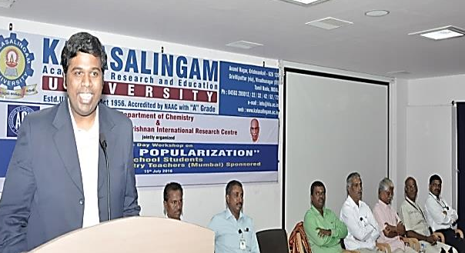
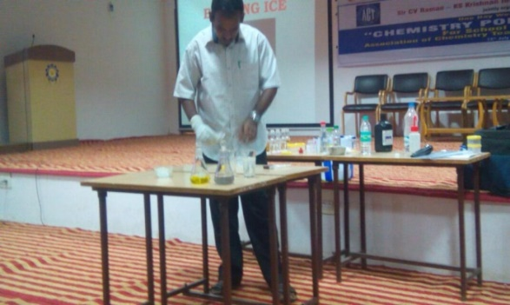

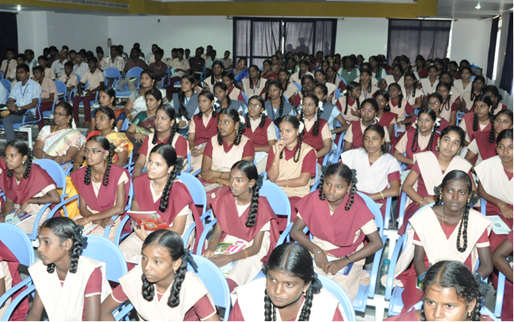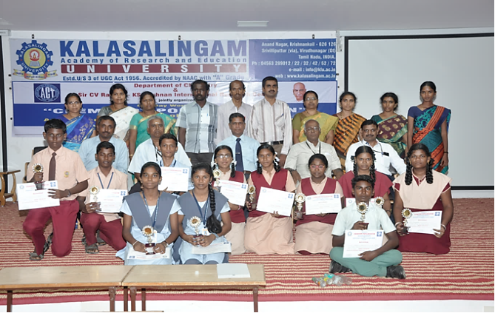

☺The Department of Chemistry, SRM University, Ramapuram Campus, Chennai organized the 3rd National Conference on New Renaissance in Chemical Research (NCNRCR-2016) on 19th August 2016 in TRP Auditorium. The Conference was organized in association with the Association of Chemistry Teachers, Mumbai and Royal Society of Chemistry (South India). The Conference was inaugurated by the renowned Scientist Prof. P.S. Kalsi, Professor of Eminence, Shoolini University, Solan, Himachal Pradesh. Prof. Kalsi, Professor of Eminence, Shoolini University, Solan, Himachal Pradesh gave plenary lecture; and Dr. S. Balasubramanian, Secretary of Royal Society of Chemistry, South India; Dr. M. R. R. Prasad, Scientist – SF (Retired), Indian Space Research Organization were the other invited speakers on this occasion.

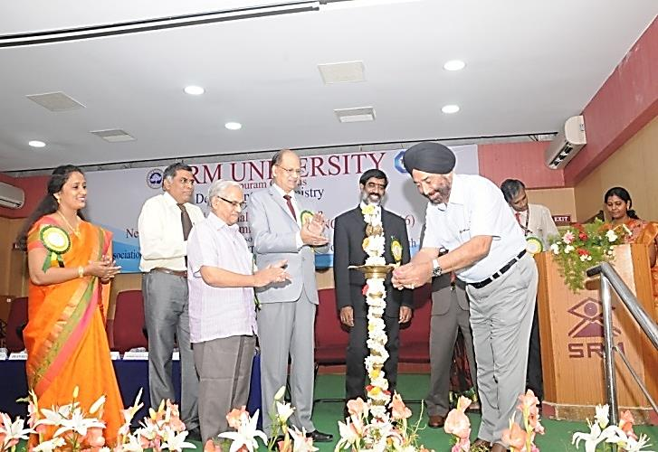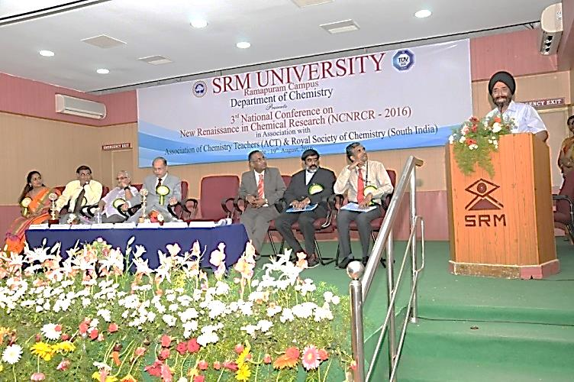
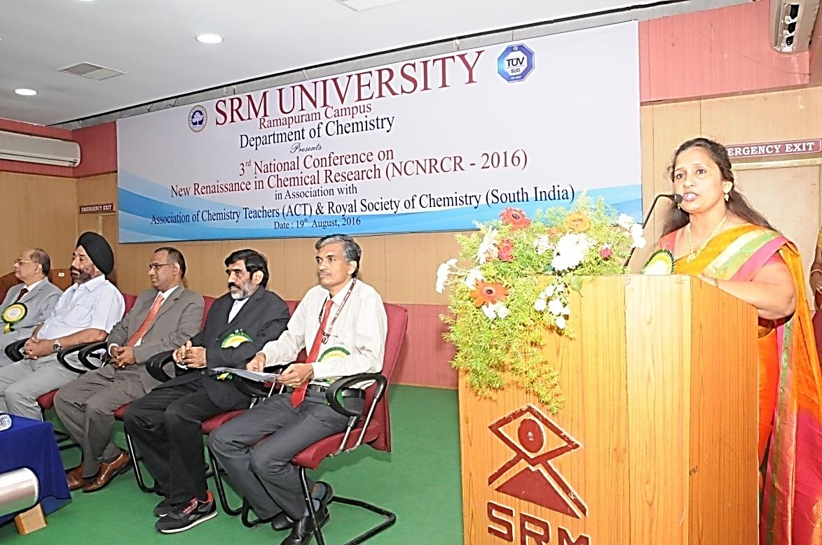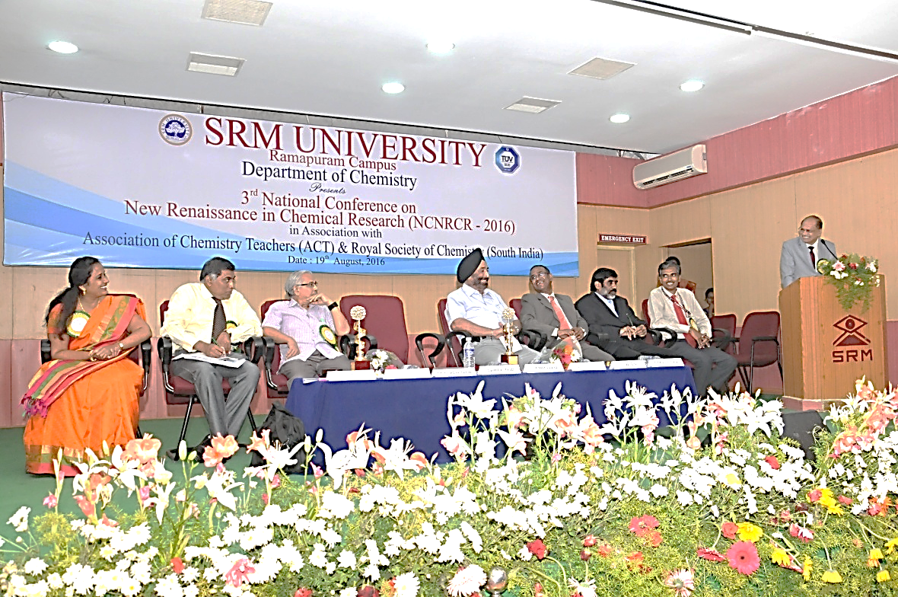
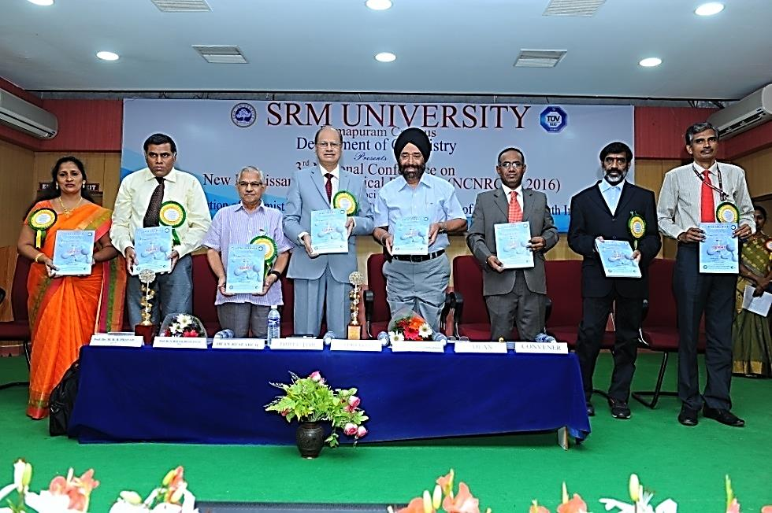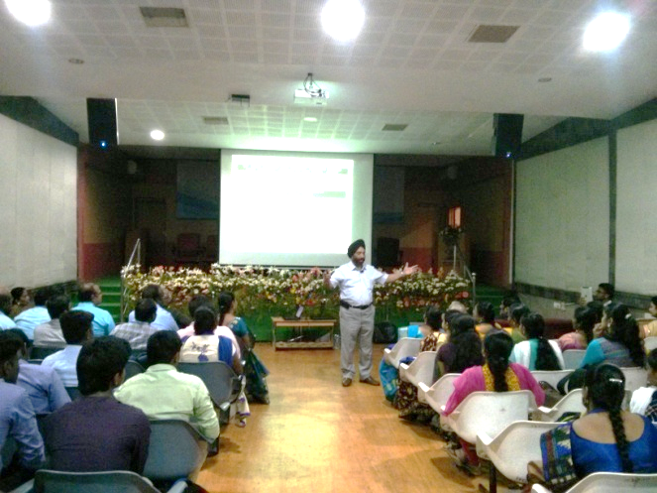
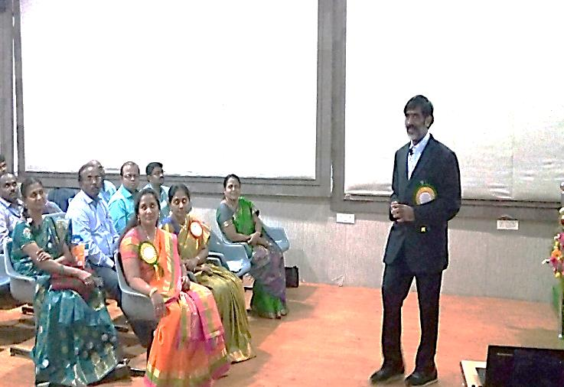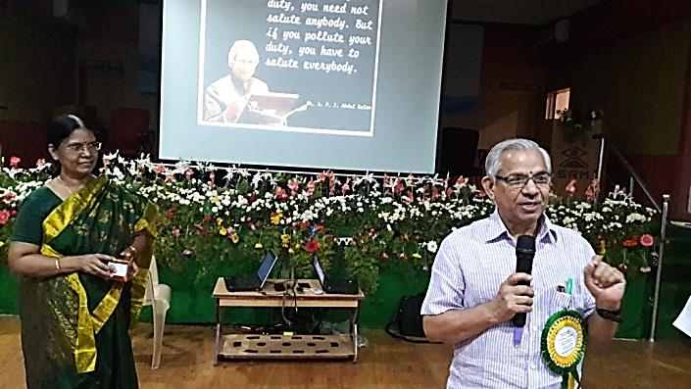
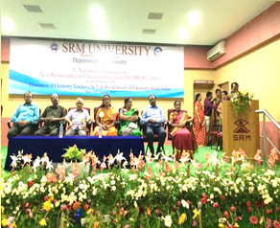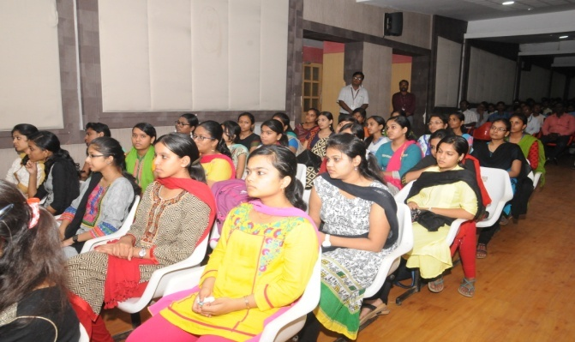
==================================================================
Harry Kroto – a co-discoverer of the Buckyball: a fond farewell

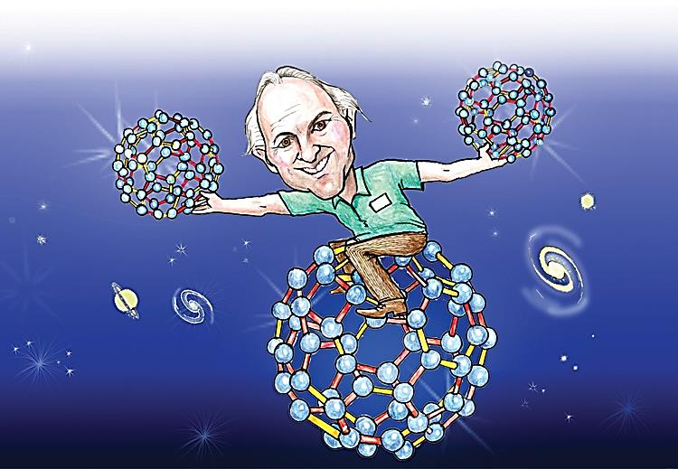

Harry Kroto is undisputedly best known for his role in the discovery of C₆₀: buckminsterfullerene. But this was only a tiny part of his life’s work, and may be surprisingly, not the piece of research he was most proud of.

In an interview with Chemistry World in 2015, Harry explained that figuring out how to make molecules containing a carbon – phosphorous double bond gave him the most intellectual satisfaction. ‘People thought you couldn’t do it,’ he explained. The 1985 discovery of C₆₀, however, was one of the trigger points for the start of a far larger research area: nanotechnology. C₆₀ was discovered almost by accident. Harry spent much of his career synthesizing straight chain carbon molecules he believed might exist in outer space, and then using microwave spectroscopy to study them and see if their signals did indeed match those being recorded from space.

As part of this work, he travelled to Rice University in the US to use an instrument designed by Richard Smalley, a co-recipient of the 1996 Nobel Prize. They zapped graphite with a laser and measured the mass of the fragments released. The team was looking for relatively low mass molecules, but it turned out the C₆₀+ ion was the dominant fragment.

They worked out that molecule must be shaped like a football, and Harry coined it buckminsterfullerene after the architect Buckminster Fuller who designed similarly – structured geodesic domes.

Publication of this work was followed by five years of balking from disbelieving members of the scientific community. But eventually, larger quantities of C₆₀ were synthesized and proved to have a perfect spherical shape. This was the 1st new form of carbon to be discovered for millennia, and it spawned the synthesis of many others. Of those made by Harry, he often said C₂₈ was his favorite.

For Harry, there was always an unfinished chapter in the tale. No-one had actually found evidence that C₆₀ exists in space. But two years ago a research team finally proved C₆₀+ ions are all over the galaxy: a finding that thrilled Harry.

After winning a Nobel Prize, Harry dedicated much of his time to education and lending his voice to various campaigns he supported. Funding for fundamental science was a topic he frequently spoke passionately about.

But it is his education work for which many of us have our fondest memories of Harry. I myself met him with a buckyball made of modeling balloons upon his head. He was enthusing a group of university students about the merits of a scientific career during a boat trip on Lake Constance in southern Germany at the time, but I suspect many of you could tell similar tales of a charismatic Harry finding ways to simultaneously thrill and educate young people all over the world. And with that I say farewell to a stellar scientific educator: you will be missed.

Sir Harry Kroto, 1939 – 2016.
===========================================================================
Acids and Bases: Creating Solutions
Morag Easson explains how to neutralize student difficulties.

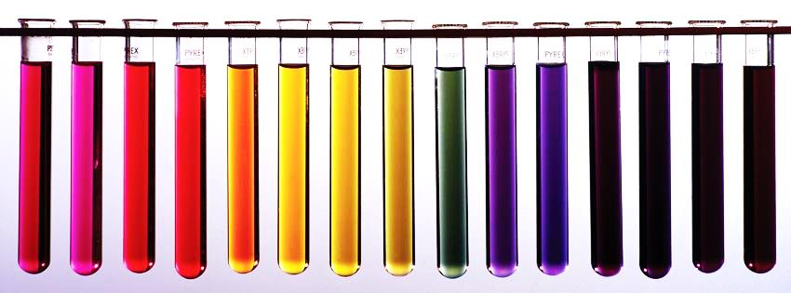

The chemistry of acids and bases can appear wonderfully colorful, but occasionally mysterious to some students. Their understanding can be hindered by confusing language and a lack of appreciation of what exactly is happening in solution at the particle level. Getting to grips with the mathematical manipulations and logarithms required can lead some to perceive acids and bases as a tricky area of chemistry. The need to apply equilibrium concepts or understand indicators at an advanced level can add to student’ worries.

Research describes what students find difficult about acid-base chemistry. This is reflected in the approaches outlined here to support students in their learning.

Common Difficulties:
Acids and bases are all around us, including a diverse array of food, drink and domestic products, providing many opportunities to explore real context and application of chemistry. However, the over-exaggerated portrayal of acids in the media as highly corrosive substances that ‘eat away’ materials in their path is likely to be familiar to students and can be unhelpful. Indeed, some bases are even more corrosive, and yet bases don’t share the reputation of their acidic counterparts. The corrosive nature of alkalis could be highlighted by posing a question such as, ‘Which are the most dangerous, acids or alkalis?’ as a topic for discussion.

Many teachers introduce the idea of acids and p^{H} with a simple and robust practical activity testing the p^{H} of everyday items with a p^{H} paper or universal indicator. Sufficient examples of bases should be included to ensure their familiarity from the outset. Students can be encouraged to test domestic items, from fruit juices to cleaning products.

The p^{H} scale poses its own challenges. The number scale can, at first, appear ‘back to front’, as the lower the number the more acidic is the solution. However, students usually accept this concept quickly and are able to use the scale to measure p^{H}. They may need reminding that the p^{H} scale ranges from 0 and above 14, even though most examples met in school lie between the two.

Zooming in on Neutralization
Neutralization reactions are very useful and common in daily life. For example, toothpaste is alkaline in order to neutralize acids in the mouth that would otherwise damage our teeth. The underlying chemistry is important in explaining the behavior of acidic solutions. Before launching into these concepts, it is essential students have a basic understanding of what happens when ionic substances are added to water.
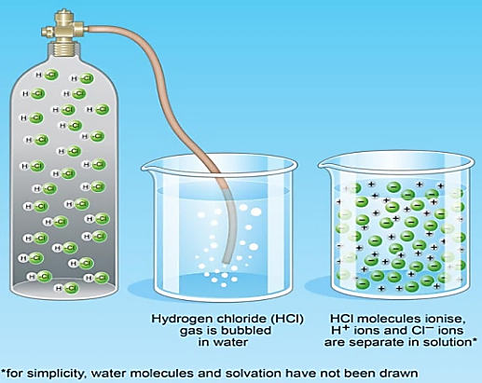
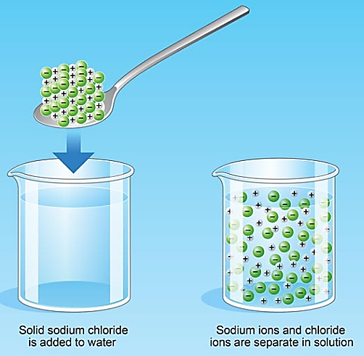

Figure 1: What happens when an ionic solid (left) or gas (right) is added to water?
© Peter Bull Art Studio
Some students hold the notion that a base somehow halts the acidic behavior of an acid. They need to appreciate neutralization is the chemical reaction of an acid and a base. Such difficulties rationalizing the behavior of acids can be addressed by considering the particle nature of solutions of acids and alkalis, and the underlying reaction as hydrogen ions react with hydroxide ions.

One possible approach, measuring the temperature change during neutralization, shows the reaction gives out heat energy as the net result of bonds breaking and new bonds forming. A thermometric titration between a strong acid and a strong alkali involves measuring the temperature and p^{H} of the resulting solution after every addition of reagent. Plotting the values shows the maximum temperature occurs at the neutralization point.

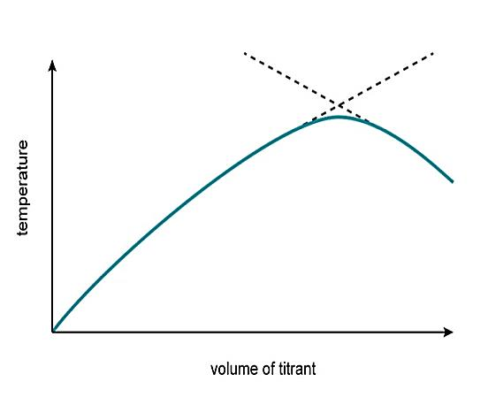 Making salts is a worthwhile activity that can also help students to explore the concept of neutralization. For example, the preparation of stunning blue copper sulfate crystals from the reaction of copper oxide and sulfuric acid, on a small scale, is very satisfying and deepens students’ understanding when the reasons for each practical step are absolutely clear, e.g. why they are adding the solid reagent in excess?
We often introduce simple salts and how to name them early on in our studies of neutralization reactions. Students’ interest can be sustained with an approach that includes some mind games such as Gridlocks or card sorts to challenge and motivate them. Writing simplified ionic equations that highlight the ions taking part in the reaction can also help students to focus on the underlying reaction.

Confusing Language
As in many areas of chemistry, language matters. The classic confusion regarding acids and bases is to mix up the terms strong and weak with concentrated and dilute. They have entirely different meanings in this context. Strong / weak refers to the degree of dissociation, while concentration is a measure of the amount of solute present in a given solvent. Perhaps our everyday language can share the blame for interchanging these words. How often have you heard someone ask for a ‘weak cup of tea’ or a ‘strong cup of coffee’?
===========================================================================

APPROACHES AND ACTIVITIES TO HELP UNDERSTAND WEAK/STRONG
- Many teachers encourage practical activities showing differences in pH, conductivity and reactivity (e.g. magnesium or marble chip) between hydrochloric acid (strong) and ethanoic acid (weak).
- Keith Taber’s Acid strength paper activity provides a useful tool to check or reinforce understanding at the particle level with older students.6 This may be enhanced by making physical models, e.g. with Lego bricks (figures 2–6).

- The PhET acid–base online simulation is great for visualizing particles and the relative numbers of particles in solution.

- Students can make sequential 10-fold dilutions of equimolar solutions of a strong acid and a weak acid. Measuring the pH at each dilution will show the pH changes by 1 pH unit for every 10-fold dilution for the strong acid but only by 0.5 of a pH unit for the weak acid. A similar comparison can be made with strong/weak bases.

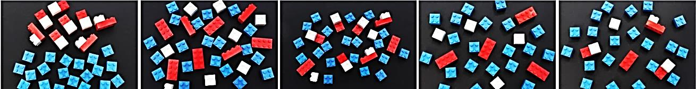
Figures 2–6, from top: acid molecules and water; strong acid ionized in water (concentrated); weak acid ionized in water (conc.); strong acid (dilute); weak acid (dilute)
© Morag Easson

How about the words ‘base’, for a substance that reacts with acids, and ‘alkali’, used to describe a water-soluble base? The difference needs to be made explicit so as not to leave students confused.

In post-16 studies, what exactly does ‘neutral’ mean? Neutral is often inadequately defined as p^{H} = 7. Neutral occurs when the hydrogen ion concentration is equal to the concentration of hydroxide ions in aqueous solution. This may or may not be p^{H} = 7 as the equilibrium is temperature dependent, thus the p^{H} (a measure of H⁺ ion concentration) varies accordingly.
=====================================================================================

APPROACHES AND ACTIVITIES TO HELP UNDERSTAND ‘NEUTRAL’

- Consider how terms are presented to students and used at different stages in school. Like many concepts in chemistry, the meaning of ‘neutral’ appears to change or be refined as students’ progress. In pre-16 studies, it is acceptable to consider neutral as pH 7 because students do not yet have the necessary knowledge and understanding of other underlying chemical concepts – e.g. equilibria.

- Practical determination of titration curves involving weak acids shows the equivalence point is not 7. Using data loggers can provide lots more example data.

- Look at experimental data collected at different temperatures and explain trends in terms of the equilibrium, H₂O (l) + H2O (l) ? H3O+ (aq) + OH–(aq) and which way it shifts. For example, a shift to a higher concentration of H3O+ ions gives a lower pH value.
- In advanced studies, the class could be given a lateral thinking problem to discuss – for example, 'a neutral salt solution is pH 6.5' – in order to get students to critically engage with the topic and explore their own ideas.

The p^{H} scale and Mathematics:
Logarithms, in particular, can look scary. Demystifying logs by explaining that we use them to make powers of ten more manageable; showing that working with logs boils down to simple addition and subtraction which is easier to handle; and practicing which buttons to press on the calculator, can be beneficial. There are some good sources of help, including the standard form topic on the freely available online CPD for Teachers course, Mathematics Skills.
Morag Easson is a Royal Society of Chemistry trainer and independent science education consultant.

Reference:
- V. Kind, Beyond Appearances: students’ misconception about basic chemical ideas (2nd Ed.). Royal Society of Chemistry, 2004.
- D. Warren, Sch. Sci. Rev., 2016, 360, 37.
===========================================================================
Surprising Hofmeister Effects on the Bending Vibration of Water

The Hofmeister series, which originally described the specific ion effects on the solubility of macromolecules in aqueous solutions, has been a long-standing unsolved and exceptionally challenging mystery in chemistry. The complexity of specific ion effects has prevented a unified theory from emerging. Amounting efforts have suggested that the interactions among ions, water and various solutes play roles. However, among these interactions, the binding between ions and solutes is receiving most of the attention, whereas the effects of ions on the hydrogen-bond structure in liquid water have been deemed to be negligible.

In this study, attenuated-total-reflectance Fourier Transform Infrared Spectroscopy is used to study the infrared spectra of salt solutions. The results show that the red- and blue- shifts of the water bending band are in excellent agreement with the characteristic Hofmeister series, which suggests that the ions’ effects on water structure might be the key role in the Hofmeister phenomena (Source: Chem. Phys. Chem., July, 2016).
Surface tension can sort droplets for biomedical applications

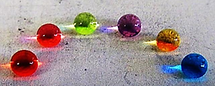Scientists describe their most recent innovation in engineered superomniphobic surfaces. (Credit: Sanli Movafaghi / Colorado State University). Imagine being able to instantly diagnose diabetes, Ebola or some other disease, simply by watching how a droplet of blood moves on a surface.
Reference: S. Movafaghi, W. Wang, A. Metzger, D. D. Williams, J. D. Williams, A. K. Kota. Tunable superomniphobic surfaces for sorting droplets by surface tension. Lab. Chip, 2016, DOI: 10. 1039/C6LC00673F
=================================================================================
Scientists unlock ‘green’ energy from garden grass
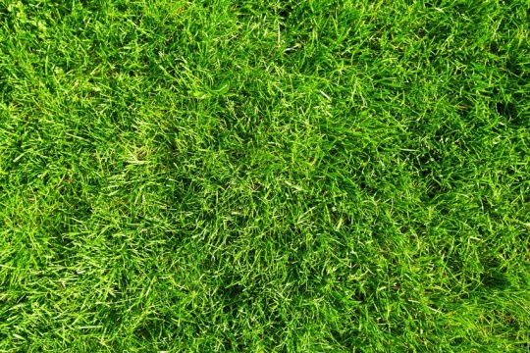 Garden grass could become a source of cheap and clean renewable energy, scientists claim.
Credit: © Kurhan / Fotolia
Reference: A. Caravaca, W. Jones, C. Hardacre, M. Bowker, H₂ production by the photo catalytic reforming of cellulose and raw biomass using Ni, Pd, Pt, and Au on Titania. Proceedings of the Royal Society A: Mathematical, Physical and Engineering Science, 2016, 472 (2191): 20160054 DOI: 10. 1098 / rspa.2016.0054
===========================================================================
Scientists program cells to remember and respond to series of stimuli
New approach to biological circuit design enables scientists to track cell histories.

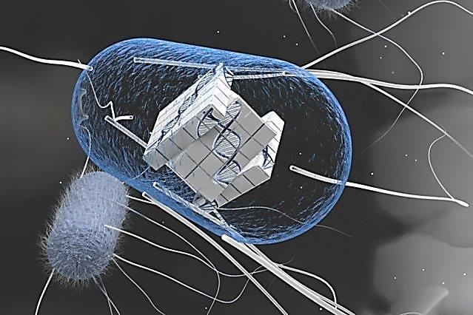 "You can build very complex computing systems if you integrate the element of memory together with computation," says Timothy Lu, an associate professor of electrical engineering and computer science and of biological engineering, and head of the Synthetic Biology Group at MIT's Research Laboratory of Electronics.
Credit: Courtesy of the researchers

Reference: Nathaniel Roquet, Ava P. soleimany. Alyssa C. Ferris, Scott Aaronson, Timothy, K. Lu. Synthetic Recombinase-based state machines in living cells. Science, 2016 DOI: 10.1126/science.aad8559
===========================================================================
Scientists create new thin material that mimics cell membranes
Nature-inspired synthetic membranes could aid water purification, energy, and healthcare needs.
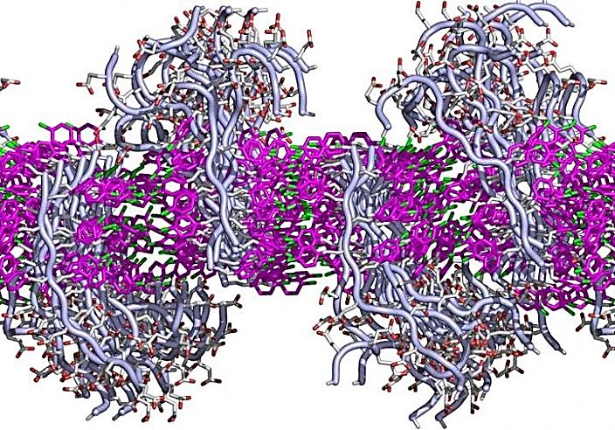 This simulated cross-section shows how the lipid-like peptoids interact to form a membrane. Each peptoid has two sections: a fatty-like region that interacts via benzene rings (shown in pink) with its neighbors to form a sheet. And a water-loving region that juts above or below the flat sheet. Each region can be designed to have specific functions.
Credit: Chun-Long Chen/PNNL

Reference:
HAIBO Jin, Fang Jiao, Michael D. Daily, Yulin Chen. Highly stable and self-repairing membrane-mimetic 2D nanomaterials assembled from lipid-like peptoids. Nature Communications, 2016, 7: 12252 DOI: 10.1038/ncomms12252

===========================================================================
Forthcoming Events:
- Concept Test in Chemistry for Under Graduate Students (CONTECH-2016) on September 24, 2016. Prof. Subhash Prasad Singh, A. N. College, Patna – National Coordinator.
- Two Day national Seminar on NMR Spectroscopy and its Biomedical applications (NSNBA – 2016), Co-sponsored by KSCSTE, Kerala and in association with the association of Chemistry Teachers (ACT), Mumbai is scheduled for October 06-07, 2016, and is being organized by the Dept. of Chemistry, Mar Ivanios College (Autonomous), Thiruvananthapuram, Kerala.
- National Convention of Chemistry Teachers (NCCT-2016), October 21-23, 2016; Raja N. L. Khan Women’s College, Midnapore, West Bengal – Dr. Jayasree Laha, Principal – Convener.
- National Standard Examination in Chemistry (NSEC – 2016) – a 1st stage examination leading to participation in the Indian National and International Chemistry Olympiad Examinations; November 27, 2016 over 1, 350 centers across the country.
- Applications are invited from Junior College / High School teachers (Teaching at X to XII standards), involved in teaching Chemistry for the exposure camp towards Chemistry Olympiad, scheduled to be held during November 21-24, 2016 at Homi Bhabha Center for Science Education (HBCSE), Mumbai. Only those teachers who are employed in schools recognized by state and central government Education Boards are eligible to apply.

- 53rd Annual Convention of Chemists, Indian Chemical Society, Kolkata is being organized at GITAM Institute of Science, GITAM University, Visakhapatnam (A.P.) -December 27-29, 2016.
========================================================================
https://www.facebook.com/cbstechnology/photos/a.771071322904772.1073741827.771069152904989/1370780542933844/?type=3
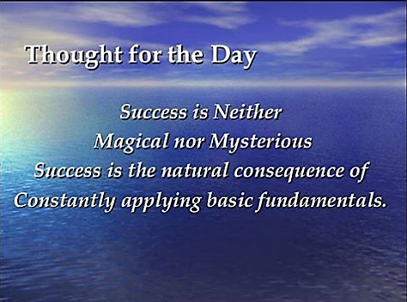
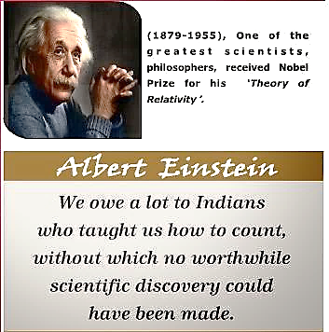
=========================================================================
Editorial Board
Dr. M. R. R. Prasad, Editor – in - Chief
Dr. D. C. Deka Dr. Subhash P. Singh Dr. Altaf Pandit
Dr. K. Sudhakar Babu Dr. (Mrs.) Helen Kavitha Dr. P. V. S. Machiraju
===========================================================================
